**Part (b):**

Uniform Case:

n <- 5  
vector <- c()  
x <- runif(n, 0, 1)  
vector <- c(vector, x)  
plot(ecdf(vector), cex = 0.6, col = "#666666", main = "n = 5")  
curve(punif(x), add = TRUE, col = "#CC99FF", lwd = 2)

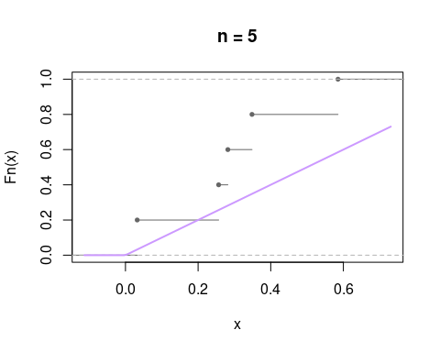

n <- 20  
vector <- c()  
x <- runif(n, 0, 1)  
vector <- c(vector, x)  
plot(ecdf(vector), cex = 0.6, col = "#666666", main = "n = 20")  
curve(punif(x), add = TRUE, col = "#CC99FF", lwd = 2)

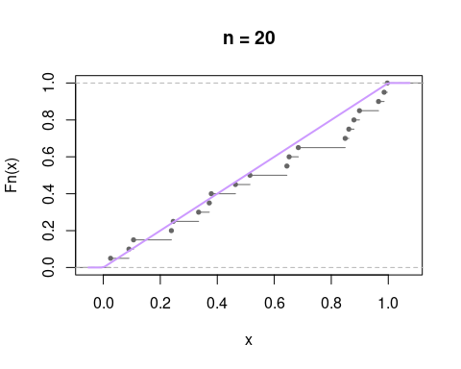

n <- 500  
vector <- c()  
x <- runif(n, 0, 1)  
vector <- c(vector, x)  
plot(ecdf(vector), cex = 0.6, col = "#666666", main = "n = 500")  
curve(punif(x), add = TRUE, col = "#CC99FF", lwd = 2)

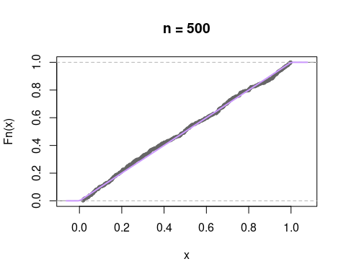

Exponential Case:

n <- 5  
vector <- c()  
x <- rexp(n, rate = 3)  
vector <- c(vector, x)  
plot(ecdf(vector), cex = 0.6, col = "#666666", main = "n = 5")  
curve(pexp(x, rate = 3), add = TRUE, col = "#CC99FF", lwd = 2)

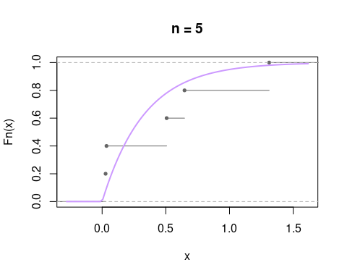

n <- 20  
vector <- c()  
x <- rexp(n, rate = 3)  
vector <- c(vector, x)  
plot(ecdf(vector), cex = 0.6, col = "#666666", main = "n = 20")  
curve(pexp(x, rate = 3), add = TRUE, col = "#CC99FF", lwd = 2)

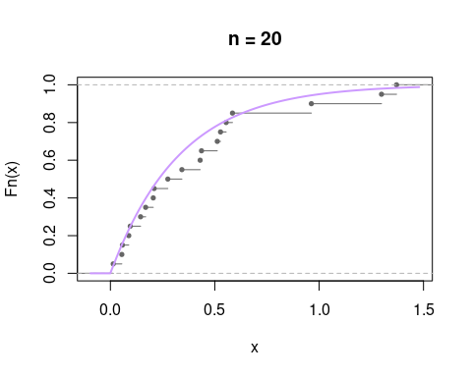

n <- 500  
vector <- c()  
x <- rexp(n, rate = 3)  
vector <- c(vector, x)  
plot(ecdf(vector), cex = 0.6, col = "#666666", main = "n = 500")  
curve(pexp(x, rate = 3), add = TRUE, col = "#CC99FF", lwd = 2)

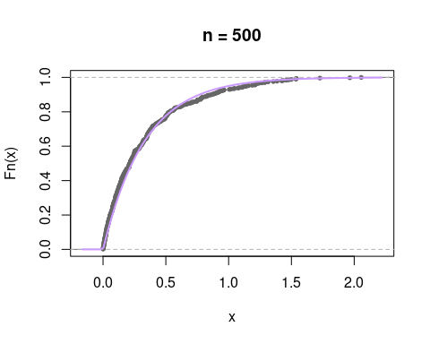

**Part (c):**

vector <- quakes[ ,4]  
plot(ecdf(vector))

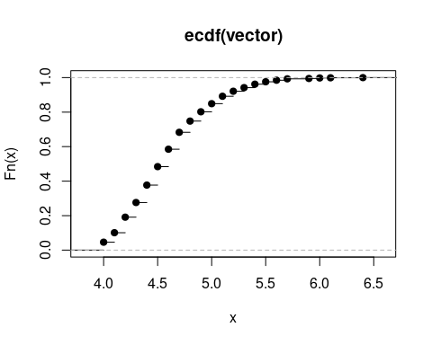

vector <- quakes[ ,4]  
hist(vector)

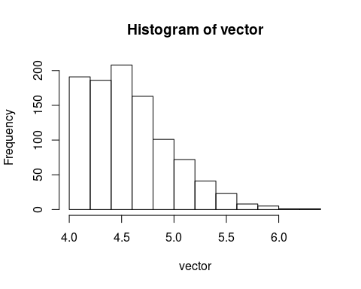

print(mean(vector))

## [1] 4.6204

print(var(vector))

## [1] 0.1622261

**Part (d):**

vector <- quakes[ ,4]  
plot(ecdf(vector))  
beta <- mean(vector)/var(vector)  
alpha <- mean(vector)^2/var(vector)  
print(beta)

## [1] 28.48124

print(alpha)

## [1] 131.5947

curve(pgamma(x, shape = alpha, rate = beta), col = "#CC99FF", add= TRUE, lwd = 2)

